Florida Neonatal Neurologic Network

PO BOX 100296, Gainesville, FL 32610
Phone: 352-273-8985
Website: http://hopefn3.org/
FSRC EIN: 59-0974739

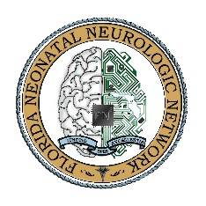
VENDOR INVITATION

June 1, 2019

Dear Valued Vendor,

You are cordially invited to attend the 9th annual meeting of the Florida Neonatal Neurologic Network.
WHEN: July 13th, 2019 12:00-17:00 (you can set up before lunch)

WHERE: Nemours Children’s Hospital
Orlando, Florida

VENDOR BOOTH REGISTRATION COST:
*STANDARD BOOTH: $750

RESERVE YOUR BOOTH NOW.

If you are interested in exhibiting at our meeting, please send an email to livia.sura@peds.ufl.edu to confirm your booth reservation.
* If you cannot reserve a booth but would like to sponsor breakfast, lunch, or afternoon snacks, please email me asap (on first come first served basis)

